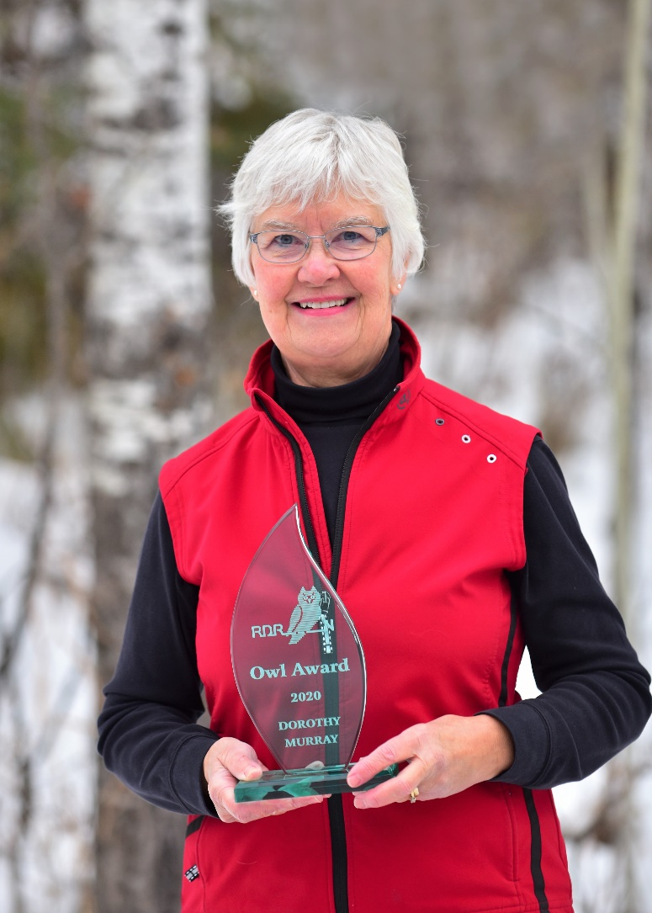
Dorothy Murray: 2020 Owl Award Presentation

When Dorothy (and Dr. Sandy) Murray returned to Red Deer in 1980, one of the first organizations they joined was the Red Deer River Naturalists. Dorothy had earned a degree in Zoology at the University of Alberta and she found that the RDRN meetings and outings provided rich supplementary learning. She fondly recalls crawling around on her knees examining wildflowers with Helen Harris and Minnie Cunningham, two RDRN wildflower experts.

Dorothy and Sandy’s young sons, Fraser and Kolin accompanied them on RDRN outings in and around Red Deer. Each outing was a learning experience and a time of camaraderie with like-minded Naturalists.
Dorothy produced 56 newsletters during the time she served as the RDRN newsletter editor from 1982 to 1989. When she retired from this position three people took over the task! She typed the newsletter up at their home, drove it out to Union Carbide to photocopy it, then handled the mailing.

For a few years, the RDRN also printed The Central Alberta Naturalist, a newsprint publication that Dorothy did some typing for. She wrote the Children’s Corner column under the name “Chickadee” and Sandy wrote a “Did You Know That” column.
Dorothy also served on the RDRN Board in 1987 and 1988, and was active on the planning committee for the 1991 Canadian Nature Federation conference. Her role was coordinating and delivering the youth program for the conference.

The opening of the Kerry Wood Nature Centre was a huge event for the Red Deer River Naturalists. From day one, Dorothy was involved with the KWNC. She delivered school programs for a short time and served on the KWNC Association Board for ten years, chairing the board for a couple of years and volunteering as the Bookstore Manager for eight. She has been the person at the front desk most Tuesdays since 1986.

Another big moment for RDRN was the opening of our office when KWNC expanded in 2005. Dorothy was part of the official opening party. She continues to serve as a RDRN ambassador at the front desk explaining to people who we are and what we do.

Fortunately for the RDRN, Dorothy kept the records of Sandy’s presentations during a busy and critical time for RDRN (e.g.: opening of KWNC, mosquito control presentation to Red Deer City Council). Some of these records may be in the Red Deer and District Archives, but she also has personal copies on hand.
We thank Dorothy for her dedication to RDRN and are pleased to present her, along with Sandy, a 2020 Owl Award.

