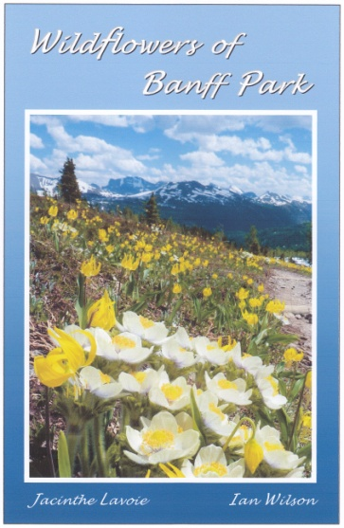

Wildflowers of Banff Park Presentation
Get a taste of summer with a multimedia presentation about wildflowers at the
on at pm.

This colourful show features the best trails for wildflowers in Banff Park, with five themes set to music ... from bold blossoms to diminutive gems, wild creatures enjoying flowers, majestic mountain scenery, and autumn colours. Presented by Ian Wilson and Jacinthe Lavoie, authors of Wildflowers of Banff Park.
After the presentation, Ian and Jacinthe welcome questions about wildflowers and photography, and will have autographed books available.

For more information, contact:

